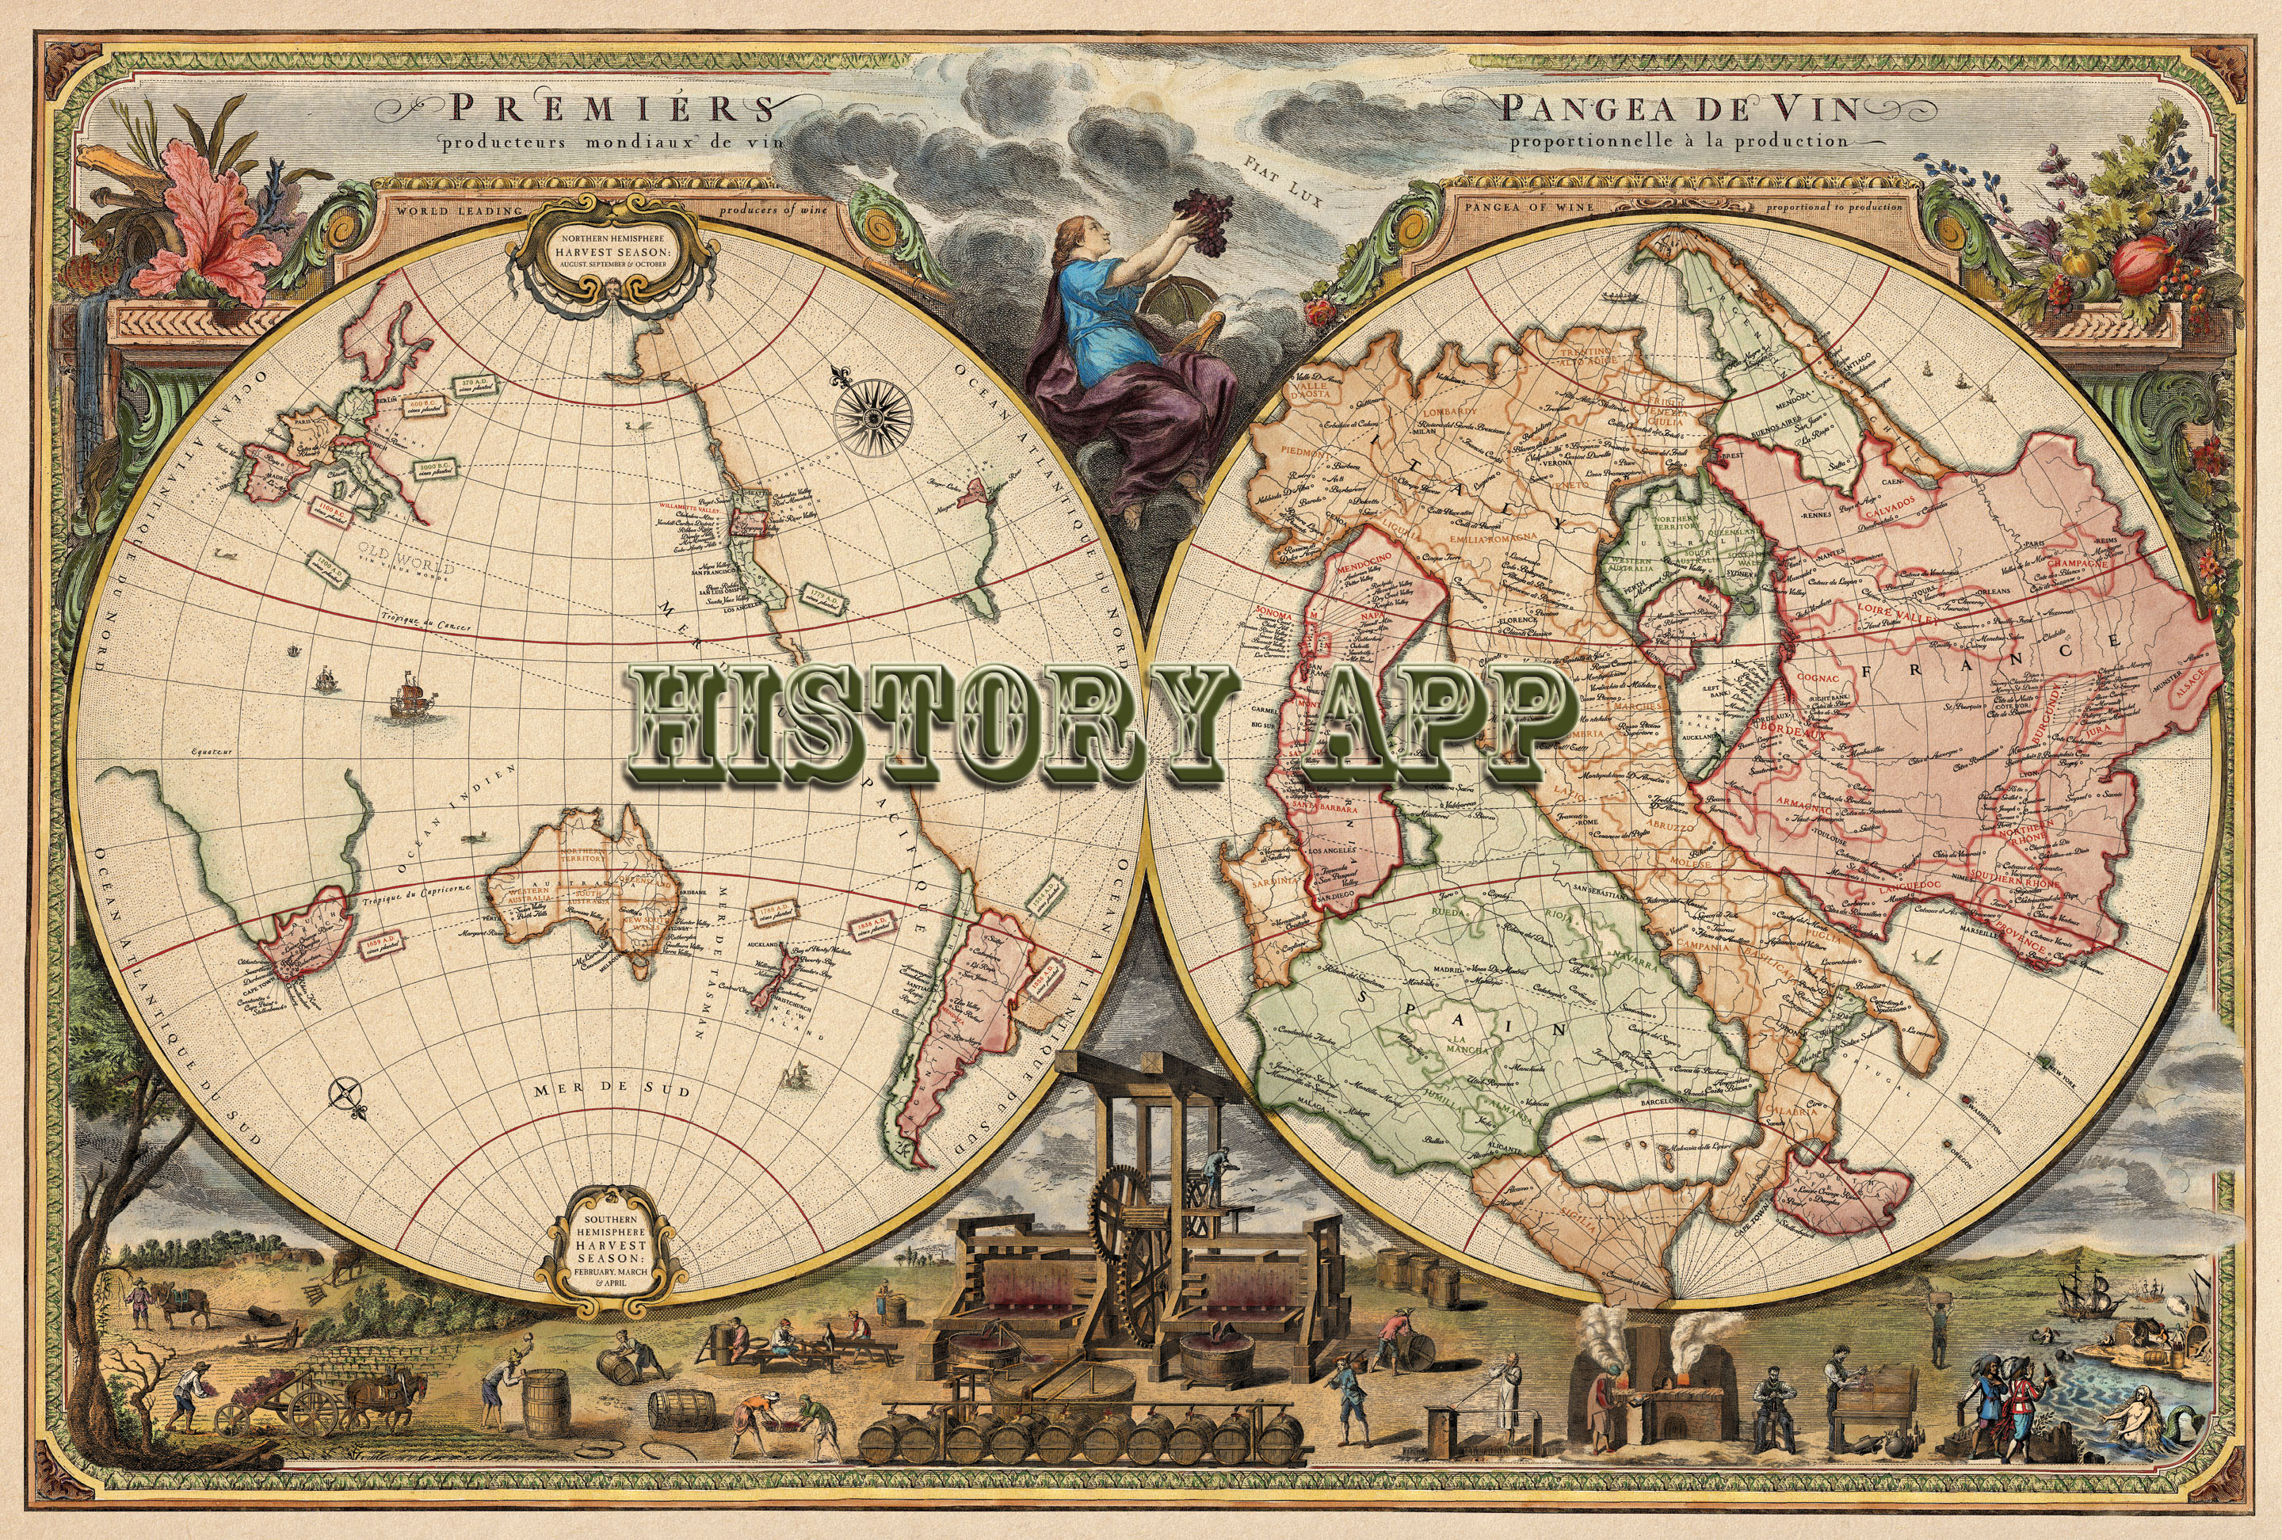

FEASIBILITY STUDY
Florida International University
Senior Project
CIS 4911
12/8/2014

Mentor:
Tracy Beeson

Development Team:
Ariel Diaz
Yesenia Yser
Revision Sheet

Release No. | Date | Revision Description
Rev. 1 | 9/8/14 | First Draft Feasibility Study
Rev: 2 | 10/4/14 | Second Draft Feasibility Study
Rev: 3 | 10/19/2014 | Third Draft Feasibility Study
Rev: 4 | 11/9/2014 | Fourth Draft Feasibility Study
Rev. 5 | 12/7/2014 | Final Revision for First Phase of History Explorer

Feasibility Study Authorization
Memorandum

I have carefully assessed the Feasibility Study for the History Explorer. This document has been completed in accordance with the requirements of the FIU System Development Methodology.

All materials available on this document are protected by copyright laws and international copyright treaty provisions. This material has been placed on this Internet site under the authority of the copyright owner for the sole purpose of viewing of the materials by users of this site. Users are not authorized to download or transmit any of these materials electronically, or to otherwise reproduce any of the materials in any form or by any means, electronic or mechanical, including data storage and retrieval systems, recording, printing or photocopying.
© 2014 FLORIDA INTERNATIONAL UNIVERSITY. ALL RIGHTS RESERVED

We fully accept the changes as needed improvements and authorize initiation of work to proceed. Based on our authority and judgment, the continued operation of this system is authorized.

_______________________________ _____________________
NAME DATE
Project Leader

_______________________________ _____________________
NAME DATE
Operations Division Director

_______________________________ _____________________
NAME DATE
Program Sponsor Representative

_______________________________ _____________________
NAME DATE
Program Area/Sponsor Director

Abstract

With the abundance of information on the web, Travelers relay on uncreditable sources, user reviews, and blogs to learn about different sites in a region. History Explorer will be a one stop application for planning vacation trip, planning your sightseeing, and learning historical information from reliable and professional sources, such as Researchers, Professors, and Scholars. This Feasibility Study Document gives a comprehensive research on similar products, product requirement and project planning phases for History Explorer.
FEASIBILITY STUDY

TABLE OF CONTENTS

Page #

1.0 GENERAL INFORMATION 1-1
1.1 Purpose 1-1
1.2 Scope 1-1
1.3 Background 1-1
1.4 Definitions, Acronyms and Abbreviations 1-1
2.0 Feasibility Study 2-1
2.1 Description of Current System 2-1
2.2 Purpose of New system 2-1
2.3 High-Level Definition of User Requirements 2-1
2.4 Alternative Solutions 2-2
2.4.1 Description of Alternatives 2-2
2.4.2 Selection Criteria 2-3
2.5 Recommendation 2-3
3.0 PROJECT PLAN 3-1
3.1 Project Organization 3-1
3.1.1 Project Personnel Organization 3-1
3.2.2 Hardware and Software Resources 3-1
3.2 Identification of Tasks, Milestones, and Deliverables 3-2
4.0 APPENDIX 4-1
4.1 Appendix A: Project Schedule 4-1
4.2 Appendix B: Feasibility Matrix 4-10
4.3 Appendix C: Cost Matrix 4-11
4.4 Appendix D: Diary Entries 4-13
5.0 References 5-0

GENERAL INFORMATION

Chapter 1: General Information

1.1 Purpose
The Feasibility Study provides an analysis of the requirements, objectives, and system concepts of the History Explorer. This includes justification as well as the tentative schedule and final artifacts. During this analysis, the objectives of the system are specified based on the required functionalities. Included in these system objectives are the high-level functional and performance goals and any assumptions and constraints. When the system objectives have been identified, the various alternatives for satisfying those objectives are determined. For each alternative, the costs in time and resources are estimated. A determination is then made as to the most feasible development alternative.

1.2 Scope
History Explorer will provide a collaborative database of historical sites for Historical Societies, History scholars and researchers, as well as tourists. This project will allow a user to receive information regarding nearby historical sites denoted by markers when they input a GPS coordinate or an address in their Android mobile device. Users will be able to create or access a route generated for them, which they can drive or walk by. Users have access to audio files, peer-reviewed documents, and images to learn about this site.
Information for this application will be inputted by the site admin via a Web application. To input data, the user will type in a GPS coordinate or an address and receive auto filled information and may attach a media or document file to this location. Also, the admin will have a Tasks page for organizing the work to be done.
For future development, the application will allow users to upload their own content, provide feedback, and peer review. Add on content will be emailed to the admin, who will then review the data for accuracy and either send it back to be reworked on or publish it. This application will also be developed for the iOS users and different levels of subscription will be created for users who wish to download the published document files.

1.3 Background
During the research for functionalities and similar applications, RoadTrippers and Trip Advisor was seen as the closest applications to History Explorer. Both Trip Advisor and Road Trippers are accessible through multi-platforms, iOS, Android, and Web Applications. However, these applications allow for trip planning, no historical information is provided. Users are able to create accounts, save locations or routes, and access this data from any device. Users are able to access links to the sites website, however, that is there only source of data, causing the user to move away from the application.

1.4 Definitions, Acronyms and Abbreviations
iOS - is a mobile operating system developed by Apple Inc. and distributed exclusively for Apple hardware.
Android - Android is a mobile operating system (OS) based on the Linux kernel and currently developed by Google.
Web Application - is any application software that runs in a web browser and is created in a browser-supported programming language (such as the combination of JavaScript, HTML and CSS) and relies on a web browser to render the application.
Database - a comprehensive collection of related data organized for convenient access, generally in a computer.
Admin - Application content administrator.
History Map Screen - Map showing nearby historical places.
Historical Place of Interest - Place with a Map Marker on the History Map Screen.
Historical Tour - Route from place A to place B which displays Historical Places of Interest along the path.
Peer-reviewed documents - Documents that have been reviewed by history scholars.
Drafted Item - a preliminary version of a piece of writing, audio or image that is sent over to the Admin to be published.
Published Item - a finished version of a piece of writing, audio or image that was approved by the Admin and is accessible by the users.
Map Marker - A visual element that is used to mark a map point within a map.
Geolocation - the process or technique of identifying the geographical location of a person or device by means of digital information processed via the Internet.
Global Positioning System (GPS) - is a space-based satellite navigation system that provides location and time information in all weather conditions, anywhere on or near the Earth where there is an unobstructed line of sight to four or more GPS satellites.
Responsive Design - a web design approach aimed at crafting sites to provide an optimal viewing experience—easy reading and navigation with a minimum of resizing, panning, and scrolling—across a wide range of devices (from mobile phones to desktop computer monitors).
Navigation systems - A GPS-based electronic system in a car or truck that provides a real-time map of the vehicle's current location as well as step-by-step directions to a requested destination.

1.5 Overview of the document
The next chapters of this document contain current functional and nonfunctional requirements for the History Map application. Chapter 2 describes the current system with its limitation and issues, new system’s purpose, alternative solutions, and future recommendation. Chapter 3 presents the overall project, including the team organization, Hardware and software requirements, and work breakdown.
Appendix A contains the current projects schedule. Appendix B contains the feasibility Matrix. Appendix C contains the cost matrix, while Appendix D holds meeting minutes and task assigned from the beginning of the project. Chapter 5 includes any references used to complete this project.

Feasibility Study

Chapter 2: Management Systems
This chapter presents the feasibility analysis of the current system, History Explorer, including its limitations, constraints and purpose of such a system. High-level requirements are discussed in details which were discuss with the client. Alternative solutions were also discussed and researched during the requirement analysis and feasibility study of this project. This chapter provides recommendations to which would make the proposed system would be best suitable for the client.

2.1 Description of Current System
Navigation systems routes a user with their current GPS location to a destination. In the user interface, an address is inputted and the device will identify, with the map, different routes for the user to take to reach the destination. Constantly tracking their GPS location, it will navigate the route depending on the user’s preference, quickest route, avoid traffic, avoid highways, etc. New models of navigation system introduce current traffic, construction, detours, and accidents. Restaurant, gas stations and auto repairs are also included and searchable via a navigation device.

2.2 Purpose of New system
History Explorer connects you with the past. It provides accounts of historical places and events while making it accessible at the palm of your hand. This application gets its content from the vast knowledge of many historians and their years of experience in the field. You will be able to see a map showing all of the historical places of interest around you and History Explorer will show you the exact address of the place, hours of operation, and phone number. It will also present you with peer-reviewed files that elaborate on the history of the place. This Android application grants you access with an archive of audio, images and documents that have been peer reviewed by professionals. History Explorer allows you to take a tour through your city while giving you detailed accounts of the events that once happened where you’re standing!

2.3 High-Level Definition of User Requirements
The implementation of the History Explorer will include the following main functionalities that the system shall perform:
Web Application:
- The system shall allow the admin to create a place of interest. (Use Case ID: HEW001)*
- The system shall allow the admin to edit a place of interest (Use Case ID: HEW002)*
- The system shall allow a user to submit a feedback. (Use Case ID: HEW004)*
- The system shall allow the admin to get help information about using the current page. (Use Case ID: HEW005)*
- The system shall allow the admin to view email. (Use Case ID: HEW006)*
- The system shall allow the admin to sign in. (Use Case ID: HEW009)*
- The system shall allow the admin to log out of their account. (Use Case ID: HEW010)*
- The system shall allow the admin to select a location within the map. (Use Case ID: HEW026)*
- The system shall autocomplete a place description. (Use Case ID: HEW027)*
- The system shall allow the admin to add an event to the timeline. (Use Case ID: HEW028)*
Android Application:
- The system shall allow the user to select a historical place of interest on the Map Screen. (Use Case ID: HEA001).
- The system shall allow the user to search for a specific historical place of interest. (Use Case ID: HEA002)*
- The system shall allow the user to play a media file for a specific historical place of interest. (Use Case ID: HEA004)*
- The system shall generate a historical route of their selected places of interest. (Use Case ID: HEA005)*
- The system shall allow the user to submit a feedback. (Use Case ID: HEA006)*
- The system shall allow the user to view places of interest within the timeline. (Use Case ID: HEA015)*
- The system shall allow the user to filter their search of places of interest with specific filter options. (Use Case ID: HEA016)*

2.4 Alternative Solutions
This section reviews alternative solutions discussed with the client and the research performed to provide the client with the best solution. By comparing alternative solutions, the feasibility of the project was suited to minimize the client’s risk in their investment.

2.4.1 Description of Alternatives
Responsive Web Applications
One Web Application would be created to support both Android and iOS users. Both user groups would access the site and have the same functionality however not all functionalities found in the requirements document would be fulfilled. An Admin site would be used for managing the content to be displayed to the client users.

Native Android, iOS Application and Web Application
History Explorer would be created for both Android and iOS devices. Doing this would involve a couple of challenges such as the high learning curve for developing for iOS and programming the application for Android users at the same time. A Web Application would still be used to manage the content of the application for both platforms.

Native iOS Application and Web Application
Instead of creating an Android Application for the History Explorer, an iOS application would be created. This native iOS Application would reach only iOS users. This alternative would require a rather large learning curve. A Web Application would still be used to manage the application by giving admins control over the content to be displayed to the users.

Native Android Application and Web Application
History Explorer would live in an Android application that would use a middle tier web service to gather data from the database. It would provide all of the functionalities mentioned in the requirements document but it would only be available to Android users. A web application would host the Admin side of the application. This site would allow admins to manage the Android application with ease. Developing an Android application would require a very minimal learning curve given that the developers are familiar with this platform.

2.4.2 Selection Criteria
Due to the time constraint and requirements of the project, an operational solution was weighed in with the alternative solutions. The following considerations was also needed for technical feasibility of the solution:
- Developers experience with the current solution tools
- How the learning curve would affect the overall schedule
- Availability of open source software related to the solution
- Client’s ability to obtain free media files from historical places.
- Current license software from the client
- Estimated cost of the project compared to the client’s budget
2.4.3 Analysis of Alternatives
The first alternative consisting of developing a responsive web application which the users would interact with brings some challenges to the table. The most relevant being how to introduce geolocation in a non-native app that is supposed to provide the same functionality in any platform that the system runs on. This type of approach would work well if the differences between the iOS and Android platforms were minimal. However, they are not, after doing research on the matter, we discovered that many workarounds had to be implemented for the product to run as expected in the intended platforms of iOS and Android. This brought up the question of why integrating it all into one application if we would have to address their differences in the end. It would make more sense to have separate applications for every platforms that the system is supposed to support. For this reason and the simplicity of using geolocation provided by the iOS and Android native platforms, this alternative was discarded.
This next alternative consists of developing three separate applications. There would be one Android application, one iOS application and the Admin Web application. The challenges presented by this approach consist of accomplishing all of the development for both platforms and the web app within the time slot for the project. Developing for iOS would require an extra month as a learning curve not only because of the fact that the developers are not acquainted with this platform but because the entire environment setup is completely different than what they are familiar with. This alternative was discarded mainly because it would require two extra months of work.
The third alternative focuses only in developing two applications, one which the users would interact with and the web application which would allow the admins to manage the content of what is to be displayed for History Explorer. The client side application would be developed exclusively for iOS users. This approach would include a learning curve of about a month given that the developers are not familiar with iOS or the environment in which it’s written on. This alternative was discarded based on the fact that the schedule is not flexible enough to allow for the learning curve and the developing challenges that developing for iOS would include.

2.5 Recommendation
The alternative chosen for implementing the History Explorer system consists of developing a mobile application exclusively for Android users. The content of this application would be managed through a web application by admins. The fact that the developers are the most familiar with Android would ensure that the product be done by the time specified in the requirements document. The developers would also have enough time to test the application thoroughly and address every bug found in the system with the least amount of effort. This alternative was selected to be implemented over the other ones for being the most feasible in terms of development time as well as the fact that the developers are the most familiar with the Android platform.

PROJECT PLAN

Chapter 3: Project Plan
This chapter provides a detailed account of how the project will proceed, including Gantt charts, hardware requirements, and role specification. The Project Organization specifies the role assignments for each project member. Hardware and Software Requirements specify the necessary requisites to implement and operate the History Map mobile application as well as the development environment. Finally, the work breakdown utilizes these small increments to schedule the deliverables, milestones, and tasks along with their dependencies.

3.1 Project Organization
The following table displays how the roles are broken down for the current deliverable of the project.

3.1.1 Project Personnel Organization
Table 3.1.1.1 demonstrates the current project organization. Each Individual is the project manager for the other, while fulfilling functional project roles.

Team Member | Roles
Yesenia Yser | Project Manager, Functional Analyst
Ariel Diaz | Project Manager, UI Designer
Table 3.1.1.1 Project Organization

3.2.2 Hardware and Software Resources
Trello: Each individual is granted access to the Senior Project’s Trello account to organize the software development process and to identify the projects current state.
Github: Each individual is granted access to the Senior Project’s project repository to have one centralized location to coordinate on the development.
StarUML 2 v2.0.0-beta12: For the creation of UML diagrams, use cases, and sequence diagrams.
Android Studio Beta v0.8.14: For the development of the Android application and as well as testing and emulation of the device
Google drive: Each individual is granted access to a shared Senior Project folder, which holds documentation, presentations, UML diagrams, images, and project associated data is kept.
Google hangouts: a video chat method to communicate ideas and discuss current project status and assign task.
Webcam and microphone: Used during the google hangouts video chats and provides ease of communication
Dropbox: Each individual is granted access to a shared Senior Project folder, which holds the final draft of the documents and presentations due to formatting issues with Google Drive.
Microsoft Office Suite 2010/2013: For the creation, modification, and reviewing documents and presentations.
Microsoft Project 2013: For the creation, modification and reviewing Project scheduling documents, such as GANTT Charts.
IE/Firefox/Chrome: Used to access the course, and testing the web application
Gmail: For the creation of GitHub, Trello, google drive, and drop box account, as well as communication between partners, mentor and professor.
Appium v1.3.4: Mobile Device Test Automation; used during subsystem and system testing of Android application
Selenium v2.8.0: Browser Automation used during subsystem and system testing of Web Application
NodeJS v0.10.33: Used by appium to run the automated test
Java SE 8: Android application is written in Java
Phpmyadmin v4.3.0: Administration of MySQL over the web.
Google Maps V2 API: API used for the map section of each application
PHP 5.3.0: Scripting language used to create web services
JSON 3: Content-type of the web services
Putty: Used to ssh into the server where the web application is hosted
FileZilla 3.9.0: File transfer GUI used to insert media files quickly and easily
Photoshop 1.14 CS6: Used to mock up the original design of the application
Hardware
PC: Windows 7 or 8, Mac OSX, minimum of 4GB of RAM, 100GB of hard drive memory space, and minimum of 1.86GHz pc spec
Android device: Meant for testing purposes. Minimum SDK: Android 4.3

3.2 Identification of Tasks, Milestones, and Deliverables
The project schedule created displays the goals we accomplished from Sept 1 to Dec 11, 2014. The project schedule also displays goals we wish to accomplish by the next iteration phase. See Appendix A 6.1 for detailed Gantt Chart of History Explorer’s Project Schedule.

Task Name | Start Date | End Date | Duration (days)
Determine Project | 9/1/14 | 9/3/14 | 3
Identify Domains | 9/3/14 | 9/7/14 | 4
Functional Requirements | 9/3/14 | 9/13/14 | 9
Software Requirements | 9/9/14 | 9/15/14 | 5
Draft Web App | 9/5/14 | 9/7/14 | 2
Draft Android App | 9/5/14 | 9/7/14 | 2
Project Specifications | 9/8/14 | 9/21/14 | 11
Database Deployment | 9/22/14 | 9/28/14 | 6
Subsystem Breakdown | 9/23/14 | 9/28/14 | 5
Web App Framework Research | 9/30/14 | 10/6/14 | 5
Identify User Features | 10/8/14 | 10/11/14 | 4
Web App Design | 9/30/14 | 10/19/14 | 15
Test Web App Transition | 10/18/14 | 10/19/14 | 2
Deploy to Server | 10/19/14 | 10/19/14 | 1
Android App Design | 9/30/14 | 10/20/14 | 15
Test Android Screen Transitions | 10/20/14 | 10/22/14 | 2
Fix bugs | 10/22/14 | 10/25/14 | 3
Research Google Maps | 10/21/14 | 10/26/14 | 5
Research PHP | 10/31/14 | 10/31/14 | 1
Research Android Dev | 10/21/14 | 1029/14 | 7
Research AngularJS | 10/21/14 | 10/29/14 | 7
Research NodeJS | 11/2/14 | 11/2/14 | 1
Research CoffeeScript | 11/3/14 | 11/3/14 | 1
Web App Log in Dev | 11/23/14 | 11/30/14 | 7
Web App Feedback Dev | 10/21/14 | 10/36/14 | 5
Web App Task Dev | 10/21/14 | 10/27/14 | 5
Web App Place Dev | 10/31/14 | 11/30/14 | 22
Web App Dashboard Dev | 10/24/14 | 12/1/14 | 6
Android Map Dev | 10/29/14 | 11/30/14 | 24
Android User’s location | 10/31/14 | 11/9/14 | 7
Android Search Functionality | 11/10/14 | 11/17/14 | 6
Android Nearby from DB | 11/17/14 | 11/26/14 | 8
Android Media Dev | 11/16/14 | 11/30/14 | 12
Place Details Display | 11/17/14 | 11/22/14 | 6
Customize Markers for Map | 10/29/14 | 10/30/14 | 6
Present Dev to Client | 12/2/14 | 12/2/14 | 1
Research Test Tools | 12/1/14 | 12/3/14 | 3
Create Test Cases | 12/1/14 | 12/4/14 | 5
Setup Test Environment Tools | 12/3/14 | 12/4/14 | 2
Unit Testing | 12/4/14 | 12/9/14 | 4
Integration Testing | 12/4/14 | 12/9/14 | 4
System Testing | 12/4/14 | 12/9/14 | 4
Analyze Test Results | 12/10/14 | 12/11/14 | 2
Fix Defects | 12/10/14 | 12/11/14 | 2
Feasibility Study | 9/15/14 | 10/6/14 | 16
Requirement Document | 10/7/14 | 10/27/14 | 16
Design Document | 10/28/14 | 11/18/14 | 16
Final Document | 11/19/14 | 12/9/14 | 15
Installation Manual | 12/2/14 | 12/4/14 | 3
User Guide | 12/5/14 | 12/8/14 | 2
YouTube Videos | 12/1/14 | 12/8/14 | 6
Presentation Poster | 11/28/14 | 12/4/14 | 5
Final Meeting With Client | 12/1/14 | 12/1/14 | 1
Review Documentation | 12/10/14 | 12/10/14 | 1
Submit Poster | 12/5/14 | 12/4/14 | 1
Submit Document/Source Code | 12/11/14 | 12/11/14 | 1
Final Presentation | 12/12/14 | 12/12/14 | 1
Table 3.2.1 Major Task, Milestones, and Deliverable along with duration dates for History Explorer

3.3 Cost
The following table shows the cost estimate for developing project. More details are available in Appendix C

Item | Description | Cost
Human Resources | Software Engineers Labor | $33,942.00
Hardware Tools | Laptops | $1,098.00
Hardware Tools | FIU Servers | $3,000.00
Software Tools | Android Studio Beta v0.8.14 | $0.00
Software Tools | Photoshop 1.14 CS6 | $210.00
Software Tools | PHPAdmin | $0.00
Software Tools | Google Maps V2 API | $200.00
Total cost |  | $38,450.00

Table 3.3.1 Cost Estimate for History Explorer.

APPENDIX

4.1 Appendix A: Project Schedule
This appendix demonstrates the project planning schedule for the History Explorer.
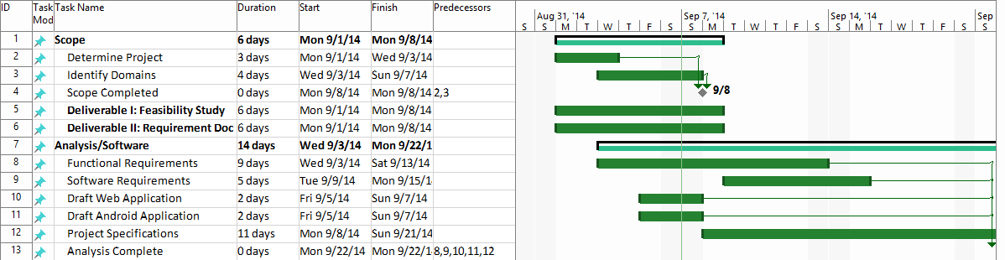
Figure 4.1.1 Project Schedule Gantt chart for First Phase of Feasibility Study
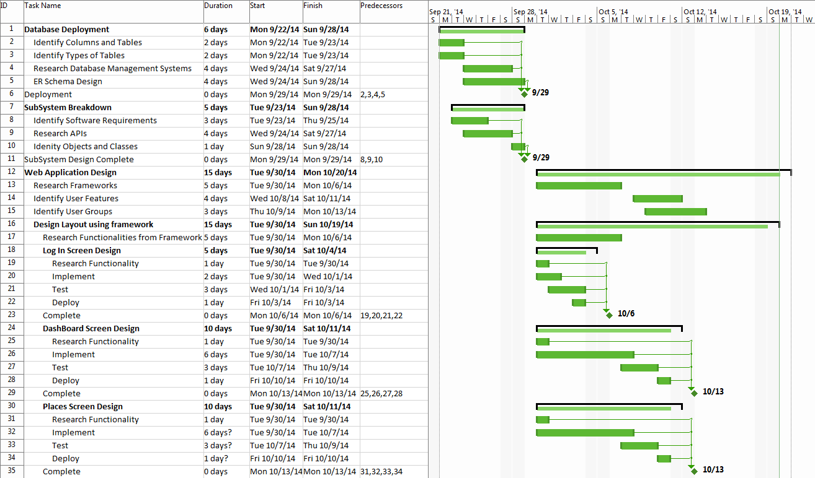
Figure 4.1.2 Project Schedule Gantt chart for Second and Third Phase of Feasibility Study
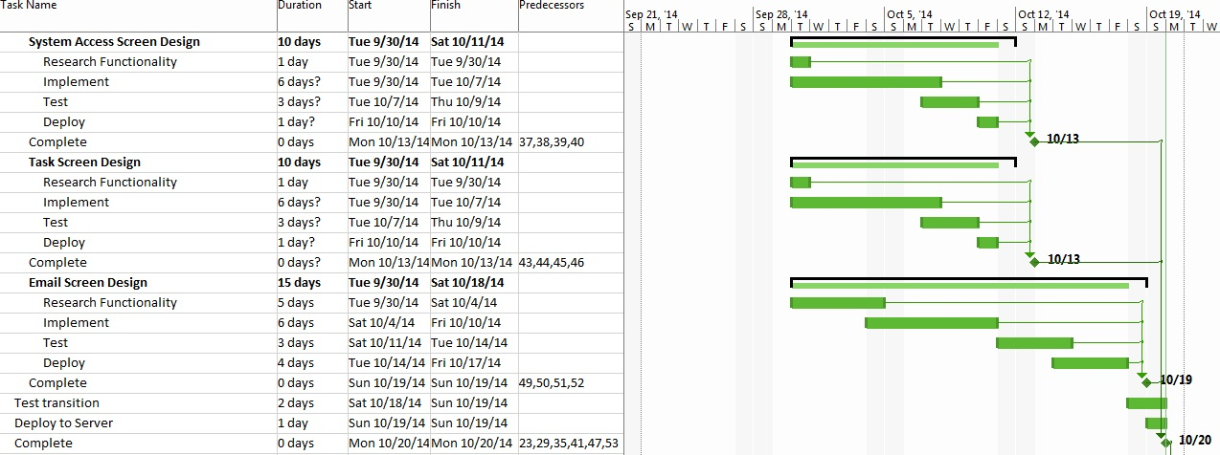
Figure 4.1.3 Project Schedule Gantt chart for Third Phase of Feasibility Study Continue
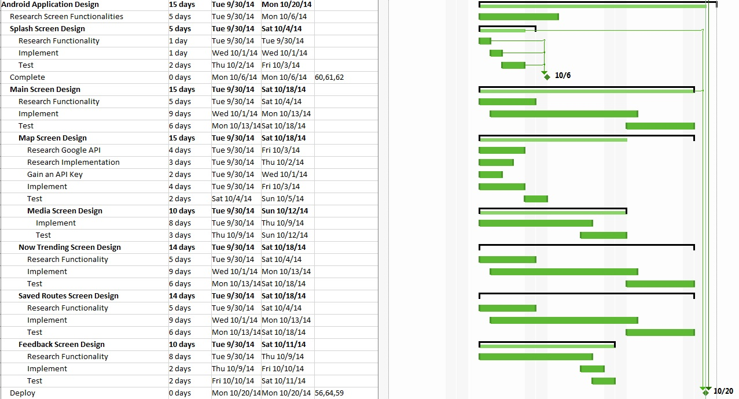

Figure 4.1.4 Project Schedule Gantt chart for Third Phase of Feasibility Study Continue
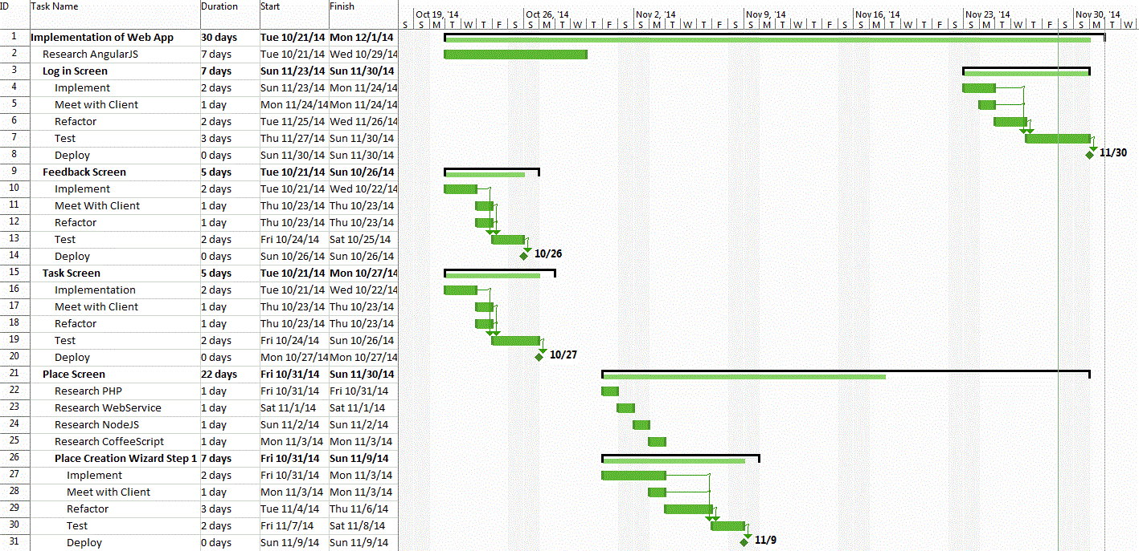
Figure 4.1.5 Project Schedule Gantt Chart for Web Application Development
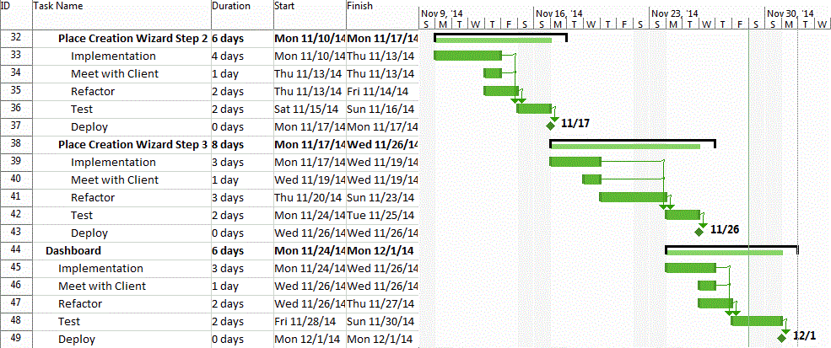
Figure 4.1.6 Project Schedule Gantt Chart for Web Application Development Continue
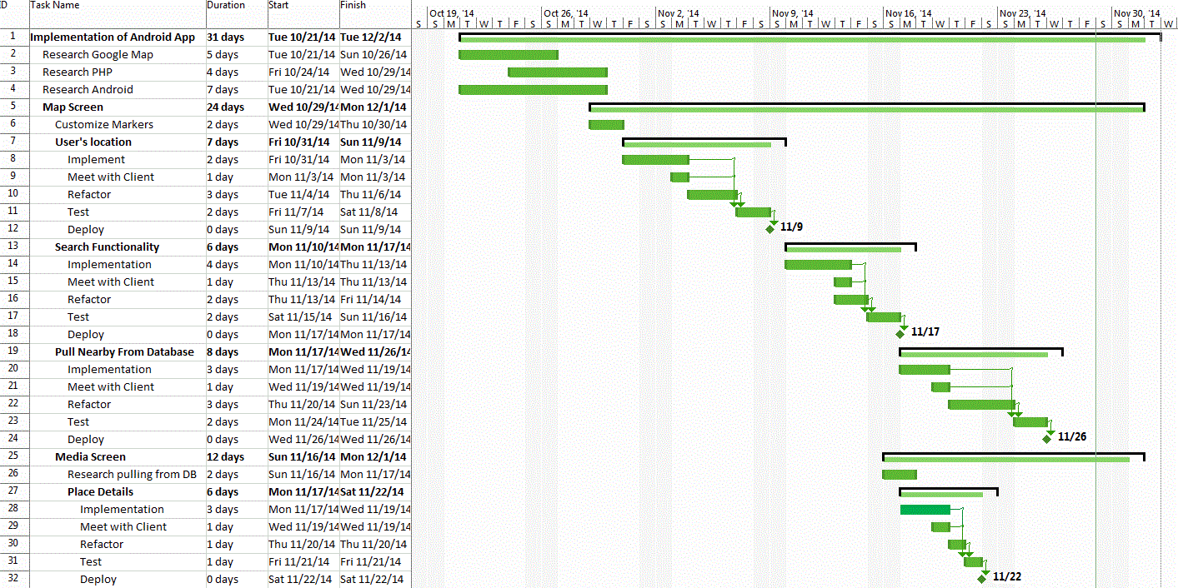
Figure 4.1.7 Project Schedule Gantt Chart for Android Application Development

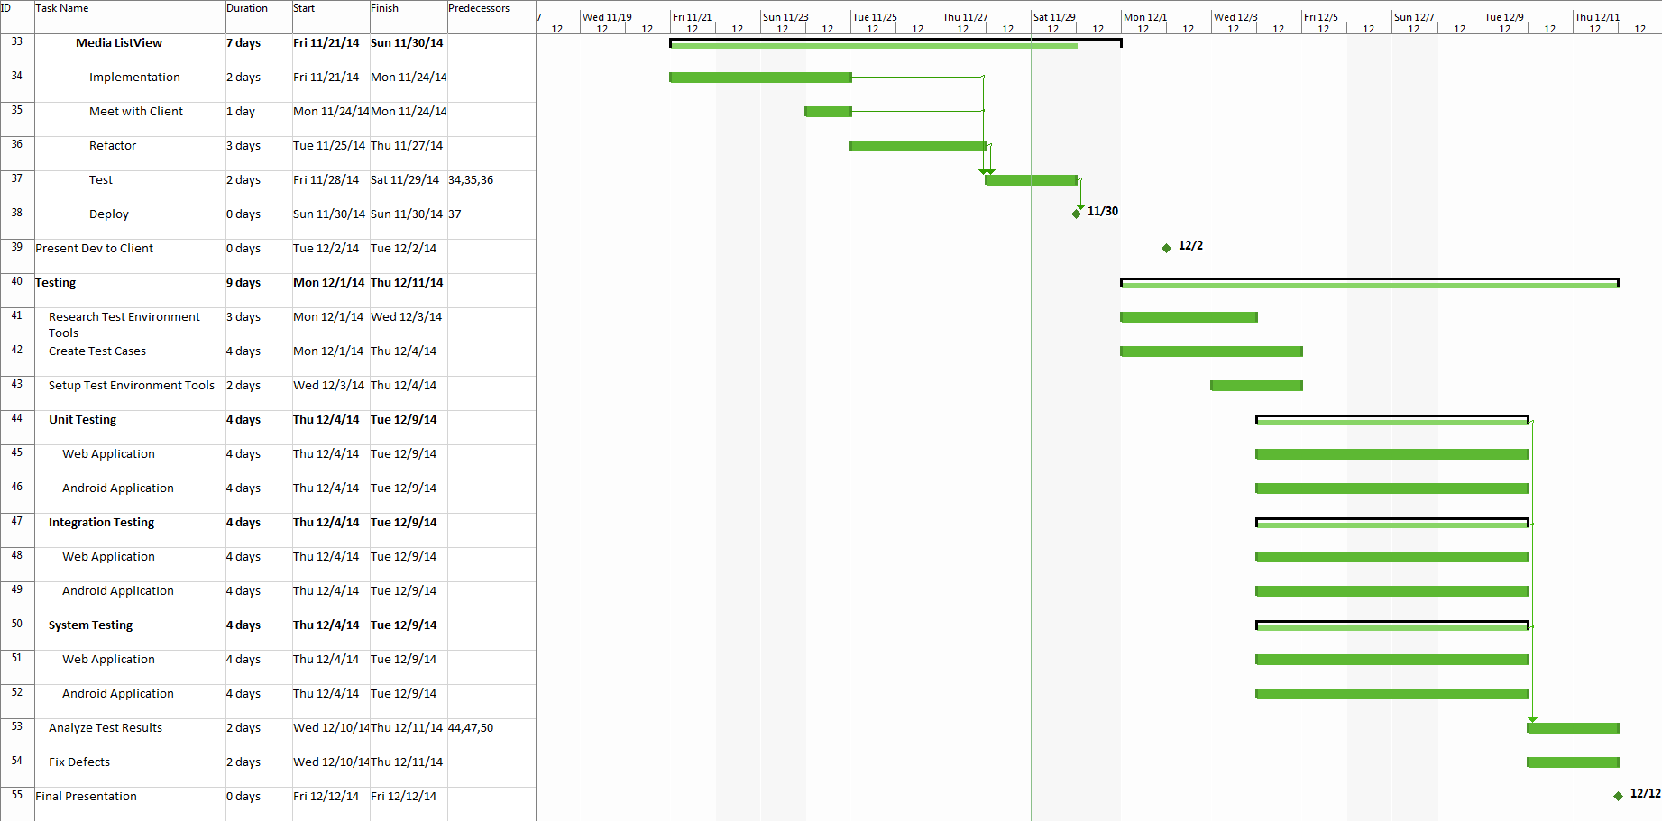
Figure 4.1.8 Project Schedule Gantt Chart for Android Application Development Continue
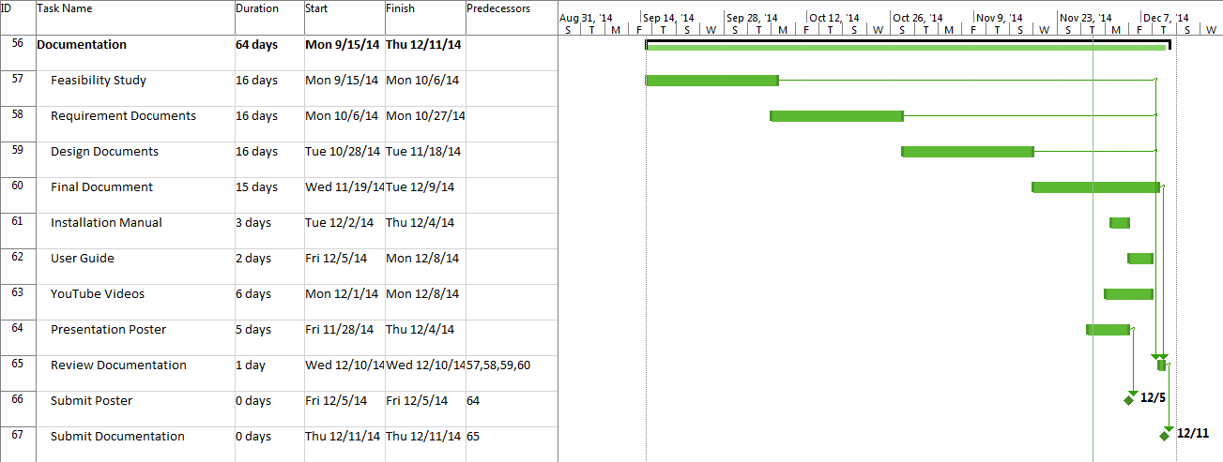
Figure 4.1.7 Project Schedule Gantt Chart for Documentation

4.2 Appendix B: Feasibility Matrix
This appendix demonstrates the Feasibility matrix table for the History Explorer Application.
Characteristics | Option 1  Native Android/Web App | Option 2  Hybrid | Option 3  Responsive Web View
Technical | Low Risk, Flexible, Future Enhancement possible; Educational  Score : 5 | High Risk, unreliable sources  Score: 3 | Unreliable sources, redundant data, low risk  Score: 3
Operational | No User Resistance  Score: 5 | User Resistance  Score: 3 | No User Resistance  Score : 5
Economical | $34,000 | $30,000 | $31,000
Expiration time | Indefinite  Score: 5 | Indefinite  Score: 5 | Indefinite  Score: 5
Estimated Configuration & Completion | 3 to 4 months  Score: 4 | 5 to 6 months  Score: 3 | 5 to 6 months  Score: 3
Total Score | 19/20 | 14/20 | 16/20

Table 4.2.1 Feasibility Matrix Table

4.3 Appendix C: Cost Matrix
This appendix will discuss the cost matrix for the History Explorer Application.
ID | Task Name | Work | Cost Per Person | Total Cost
1 | Planning | 20 hrs. | $500 | $1000
2 | Requirement Elicitation | 6 hrs. | $150 | $900
3 | Meeting with Client | 3 hrs. | $120 | $360
4 | Determine Functional Requirements | 4 hrs. | $140 | $560
5 | Determine Non-Functional Requirements | 4 hrs. | $140 | $560
6 | Initial Design Mockup | 6 hrs. | $100 | $600
7 | Initial Database Design | 6 hrs. | $150 | $900
8 | Initial System Design | 2 hrs. | $140 | $280
9 | Document Draft | 6 hrs. | $80 | $480
10 | Meeting With Client | 3 hrs. | $120 | $360
11 | Adjusting Functional Requirements | 3 hrs. | $120 | $360
12 | Adjusting Non Functional Requirements | 3 hrs. | $120 | $360
13 | Implementation of Android Design | 8 hrs. | $200 | $1600
14 | Implementation of Web Design | 6 hrs. | $200 | $1200
15 | Meeting with Client | 3 hrs. | $120 | $360
16 | Revising Android Design | 6 hrs. | $200 | $1200
17 | Revising Web Design | 6 hrs. | $200 | $1200
18 | Android Google Map Implementation | 12 hrs. | $150 | $1800
19 | Web App Google Map with Places Creation | 12 hrs. | $150 | $1800
20 | Database Creation | 5 hrs. | $80 | $400
21 | Backend Database Communication | 4 hrs. | $120 | $480
22 | Setup Testing Environment | 3 hrs. | $120 | $360
23 | Meet with Client | 3 hrs. | $120 | $360
24 | Unit Testing | 40 hrs. | $1200 | $4800
25 | Implementation Testing | 40 hrs. | $1200 | $4800
26 | Fix Defects | 16 hrs. | $450 | $900
27 | System Testing | 40 hrs. | $1200 | $4800
28 | Fix defects | 16 hrs. | $450 | $900
29 | Present final Deliverable to Client | 4 hrs. | $120 | $240
Total |  |  |  | $33,942

Table 4.3.1 Cost Matrix Table

Below are the tools that will be needed in order to successfully complete the project.

Tools | Number of Team Members | Budget
PC: 4GB Memory – 500GB HDD | 2 | $549.99
Android Studios | 2 | Free
Putty | 2 | Free
GitHub | 2 | Free
FileZilla | 2 | Free
Photoshop | 1 | $79.99/mo (3 months)
StarUML | 2 | Free
Microsoft Office Home | 2 | $139.99
Total |  | $1559.93

4.4 Appendix D: Diary Entries
This appendix includes all documented group meetings diary. Each diary consist of partners that arrived for the meeting, date and time, the agenda, a discussion of each individual's task and an overview of what was accomplished.

MINUTES
Meeting Date 9/3/2014
Time 6:15 PM
Meeting location JCCL in ECS
Meeting called by Yesenia Yser
Type of meeting Requirement/Analysis

Facilitator Yesenia Yser
Note Taker Ariel Diaz
Timekeeper Ariel Diaz

Attendees
Tracy Beeson
Ariel Diaz
Yesenia Yser

AGENDA TOPICS
Time allotted 1 hour 25 minutes
Agenda topic Requirement Analysis

Discussion:
Tracy was asked questions regarding the purpose and scope of the project. The project would not be based on an already existing application, meaning that it is to be built from scratch. The platform chosen to host the app is Android, however, a web application is to be created to manage the content to be displayed in the Android app. Content is to be added manually by the site admins. Yesenia and I are not expected to provide content for the application. Tracy wants an Android application that uses Google Maps to display historical items such as pieces of writing, images and sounds in specific locations in the map. A tour functionality is to be added. This would allow the users to follow a route which will provide them with information about historical events and places in the vicinity. The main user base is composed by tourists and historical societies/museums. Although in the future the app would expand to accommodate for professors by providing a way for them to peer review the existing historical items. Tracy plans to earn money through the application by enforcing a user subscription fee for those that would like to download the historical content being shown. We are expected to implement the database, data access, server file storage, android app and admin web app.
Conclusion:
-New application.
-Platform: Android and Web Application.
-Required Functionalities:
-Admins can manage content using the web app.
-Android app users can view historical items in the map
-Android app users can read/view/listen to the items pertaining to a historical event/location.
MINUTES
Meeting Date 9/6/2014
Time 12:30PM
Meeting location Google Hangouts
Meeting called by Ariel Diaz
Type of meeting Current Progress

Facilitator Ariel Diaz
Note Taker Yesenia Yser
Timekeeper Ariel Diaz

Attendees
Ariel Diaz
Yesenia Yser

AGENDA TOPICS
Time allotted: 25 minutes
Agenda topic Stand Up

Discussion:
Ariel Diaz has been working on the mock up interfaces for the History App, both Android and Web application. Yesenia Yser has been working on the Documentation, setting up the formatting of the document, working on milestones and a breakdown of workload, including the GANNT Chart. Trello has been updated with current tasks both members need to accomplish, from Documentation, Project environment, Web, and Android. Yesenia has also contacted the Mentor with the information to setup Trello and Github account. Features/ Use Case document has been created on the Google drive shared folder, split with Web and Android features and questions to be discussed later. Documentation was split already and identified on Trello. We will re-meet at 6:30PM to discuss the features and split the Use cases.
Conclusion:
-Re-meeting at 6pm for updates on current progress, regroup, and split the discuss Use cases
-Brainstorm Functional Requirements
-Ariel will create the Mock up Interfaces for the Web application
-Split the documentation -- See Trello “Documentation: First Draft - SRD” in Checklist, each of us placed name next to the section we wish to complete
-Split the Feasibility Study Documentation -- See Trellow “Documentation: First Draft -- FS” In checklist, each of us placed the name next to the section we wish to complete.
-Contacted Mentor for Trello and Github account creation
MINUTES
Meeting Date 9/8/2014
Time 6:15 PM
Meeting location JCCL in ECS
Meeting called by Tracy Beeson
Type of meeting Requirement/Analysis
Facilitator Yesenia Yser
Note Taker Ariel Diaz
Timekeeper Ariel Diaz

Attendees
Tracy Beeson
Ariel Diaz
Yesenia Yser
AGENDA TOPICS
Time allotted 1 hour
Agenda topic Requirement Analysis

Discussion:
After our senior project presentation and receiving feedback from Sadjadi and Juan Caraballo, we met with the Client, Tracy, to demonstrate our current mock up and ask about what new features she would like. Tracy currently liked the current mock up, however, due to the new features, these mock ups are changing as well.
We discussed the different platforms this application can be hosted on: Total Web Application, Hybrid application (For both Android and OS) or Native Platform (Android, iOS, and Web in its native form).
We also discussed the current features we will like to add:
- Recommend a site or route
- Trending Route or site
- User groups and permissions
- Task/to - do list on web application
Client was not sure of the technical details and wished to have an email with this technical details so she can research. Ariel Diaz will be sending out an email where he will explain with further details what having the project in those platforms means at a high level.
Name change was also discussed since there has not been a set name for the project. Informing Tracy that the current project being open source. These concerns and comments are in the email communication between Ariel and Tracy
Conclusion:
- Email Client with technical details for new platform and features
- Names for Application:
  - History Map
  - History Hunter
  - History Globe
  - City History
  - World History
  - History Market
  - Know your History
  - Map your History
- Admin Dashboard
  - Listing the following items:
    - Users and the functionality of upgrading their accounts
    - Popular places of interest near you.
    - Related places of interest to add to the database.
    - Statistical data regarding views for every place, and document.
    - Statistics regarding a rating system for places and documents.
- Create new Mockups to include new features
- Create use cases for new features after client approves.
MINUTES
Meeting Date 9/14/2014
Time 11:00 AM
Meeting location Google Hangouts
Meeting called by Ariel Diaz
Type of meeting Standup; New Task

Facilitator Ariel Diaz
Note Taker Ariel Diaz
Timekeeper Yesenia Yser

Attendees
Ariel Diaz
Yesenia Yser
AGENDA TOPICS
Time allotted 30 minutes
Agenda topic Standup; Assign new Task

Discussion:
Over the course of the meeting we introduced the idea of Groups, Permissions and the interaction between one another and Users of the History Explorer. We reached the conclusion that for this project we shall have use cases for creating Groups.

Each group will contain a user base as well as a set of permissions that will translate into the users being able to access different content such as the media made available by the Admins. I, Ariel, wrote the use cases for the following use cases: CreateGroup, CreatePermission, AddUserToGroup, AddPermissionToGroup.

Yesenia brought up the idea of having the functionality to recommend a specific historical route. It would basically allow the user to recommend a historical route which they have traveled through. Another idea that Yesenia brought up to the table was that of having a trending route to follow. The system basically analyzes database data and selects trending routes amongst our users and presents them to others. Use cases were written correspondingly.
Conclusion:
  - Statistical data regarding views for every place, and document.
  - Statistics regarding a rating system for places and documents.
  - Groups, Permissions and Users
  - New Features still need to be approved by client
  - Client meetings are set for
  - Task to be done By Monday Presentation:
    - Ariel
      - Finalize the current mockups
      - Write two more use cases
      - In FS document, 1.3
      - In RD, 3.3
      - Review and Unify current Use cases
    - Yesenia
      - Write two more Use Cases
      - Use Case diagram
      - Update Gantt Chart to include up to next presentation
      - In FS doc, 3.2
      - In RD, 3.2
      - Add new diary meetings to the final document
    - Together:
      - Subsystem breakdown
      - In FS,
        - 2.3 - 2.5
      - In RD,
        - Chapter 4
MINUTES
Meeting Date 9/15/2014
Time 2:00 PM
Meeting location JCCL ECS
Meeting called by Yesenia Yser
Type of meeting Standup; New Task
Facilitator Yesenia Yser
Note Taker Ariel Diaz
Timekeeper Yesenia Yser

Attendees
Ariel Diaz
Yesenia Yser
AGENDA TOPICS
Time allotted 30 minutes
Agenda topic Assign new Task

Discussion:
Ariel has been communicating with Tracy in regards with the new application name and informing her about the open source, answering any questions or concerns she may have. Nothing here has been finalize, more details will be posted when they are available. More details will be discussed via email or 9/22 after our Senior Project presentation.

During this meeting, we discuss this week task that should be completed by Monday’s presentation. Currently we will be doing Google hangouts or text chats to keep each one of us posted on the others current status or issues. An in person meeting is still in discussion for this weekend.
Conclusion:
  - New Features still need to be approved by client
  - Client meetings are set for via Google Calendar
  - Task to be done By Monday Presentation:
    - Ariel
      - Finalize the current mockups
      - Write two more use cases
      - In FS document, 1.3
      - In RD, 3.3
      - Review and Unify current Use cases
    - Yesenia
      - Write two more Use Cases
      - Use Case diagram
      - Update Gantt Chart to include up to next presentation
      - In FS doc, 3.2
      - In RD, 3.2
      - Add new diary meetings to the final document
    - Together:
      - Subsystem breakdown
      - In FS,
        - 2.3 - 2.5
      - In RD,
        - Chapter 4
    - Practice Presentation:
      - Take an hour from our meeting to finalize our presentation
      - Each individual is timed based on the standards Sadjadi has placed for presentation
      - Give each other pointers on what to focus on
      - Get a flow setup depending on who presents first
      - Make sure each individual is able to present their current status within the allocated time.
MINUTES
Meeting Date 9/22/2014
Time 6:30 PM
Meeting location ECS
Meeting called by Yesenia Yser
Type of meeting: Recurring Presentation Recap with Tracy Beeson
Facilitator Yesenia Yser
Note Taker Ariel Diaz
Timekeeper Ariel Diaz

Attendees
Ariel Diaz
Yesenia Yser
Tracy Beeson
AGENDA TOPICS
Time allotted 1 hour
Agenda topic Discuss presentation feedback with Tracy Beeson

Discussion:
- During this meeting we presented Tracy with the deltas since our last meeting. New features that we introduced are the planning of a vacation using History Explorer as well as having a timeline for a specific task. She approved both the Android application mockup and the web application mockup. Regarding tackling a heavier challenge, Tracy told us that she would get back at us after speaking with her most tech savvy colleagues and finding out about a cool feature for the product to have. We also spoke about the feedback flow from the user to the admin and she was pleased. During this meeting we also discussed the idea of having the system generate a tour based on a location. Advertisement placing was also discussed.
Conclusion:
- Tracy will contact technology savvy historians and ask them for recommendations on a more challenging feature.
- Tags shall be introduced for Tasks.
- Add Search bar to tasks
- Tracy will provide us with a reliable source where to pull data from.
- We have Tracy’s approval on the new features since our last meeting with her:
  - Vacation Route
  - My Saved Routes
  - Timeline
  - Using social media and other sources to populate a timeline.
- Look into Advertising placing for the Android application.
MINUTES
Meeting Date 9/26/2014
Time 12:00 PM
Meeting location JCCL ECS
Meeting called by Ariel Diaz
Type of meeting: Progress Report

Facilitator Ariel Diaz
Note Taker Ariel Diaz
Timekeeper Yesenia Yser
Attendees
Ariel Diaz
Yesenia Yser
AGENDA TOPICS
Time allotted 45 minutes
Agenda topic: Current Status; Next Steps

Discussion:
- Ariel has been working on designing the database schema to support users, groups, permissions, places of interest, timelines, events and the relationships among them. He has also been writing documentation and writing use cases to match the system’s functionality.
- Yesenia has been working on the live Android mockups, as well as making sure the writing of the documentation keeps moving forward with the respective use cases. She has been working to finalize the requirements for her main feature.
- We discussed how to approach the next presentation. We talked about what to present and in what order.
- We also discussed what we will be doing on the weekend. During the weekend we will finalize all of our features and prioritize them in our board. Once the list of features are final we will write the use cases to match the list.
Conclusion:
- For this meeting, Yesenia and I caught up on what each one of us has been doing, and we sorted out what our next steps are. We also went over what we will be working on during the weekend.
MINUTES
Meeting Date 9/27/2014
Time 12:00 PM
Meeting location Google Hangout
Meeting called by Ariel Diaz
Type of meeting: Standup
Facilitator Ariel Diaz
Note Taker Ariel Diaz
Timekeeper Yesenia Yser

Attendees
Ariel Diaz
Yesenia Yser
AGENDA TOPICS
Time allotted 15 minutes
Agenda topic: Plans for today

Discussion:
- By the end of today, we should have written 3 uses cases each for the functionalities that we will implement. Each one of use will tackle a chapter of documentation regarding the feasibility study document.
- We will both finalize the list of features for this project.
- Ariel will finalize the database schema design.
- Yesenia will update the Gannt Chart for this period in the project. She will also start development on the Android side of the project.
Conclusion:
- This was a short meeting about what will be done by the end of Saturday 9/27/2014 on our side.
MINUTES
Meeting Date 9/28/2014
Time 10:00 PM
Meeting location JCCL ECS
Meeting called by Yesenia Yser
Type of meeting: Deployment
Facilitator Yesenia Yser
Note Taker Ariel Diaz
Timekeeper Yesenia Yser

Attendees
Ariel Diaz
Yesenia Yser
AGENDA TOPICS
Time allotted 3 hours
Agenda topic Assign new Task, Deploy Database

Discussion:
- Setup phpmyadmin on the VM
- Ariel had finished up a local copy of the database. This was to be deployed to the VM environment. However, the remote port for MySQL to deploy the database to the VM was blocked, so phpmyadmin was setup to be able to manually input the database
- Setup a month worth of milestones and deadlines for the project. This will be used to update the Gannt Chart, as well as keeping each individual on task and being able to know the next step
- Discussed to add task into the backlog so we can prioritize features based on which features will be needed to get our main features properly created.
Conclusion:
- Finalized use case terminology, added use case IDs
- Added each feature individually to the backlog of Trello for deployment. These task, after they have been created need to be prioritized.
- Use cases were split up between each team member: four use cases were assigned in Trello to each member. These are to be completed by next Monday
- Since Use Case ID and terminology was finalized, a Use Case diagram will be needed to be created and then approved by Sadjadi
- Ariel is going to finish deploying the database into the VM, write four use cases, mockup the system design and database design for next presentation, and sequence diagram of main feature, timeline.
- Yesenia will create the Android application interface, including the transition between each activity screen, as well as the Use case diagram and the four assigned use cases to be presented next Monday
- Goal for next Monday:
  - Use Case Diagram
  - Android Interface Demo
  - System Design
  - Database Design
  - Sequence diagram of main feature
MINUTES
Meeting Date 10/6/2014
Time 6:30pm
Meeting location ECS courtyard
Meeting called by Tracy Beeson
Type of meeting Client Communication

Facilitator Yesenia Yser
Note Taker Yesenia Yser
Timekeeper Ariel Diaz

Attendees
Ariel Diaz
Yesenia Yser
Tracy Beeson

AGENDA TOPICS
Time allotted 30 minutes
Agenda topic Current Project Status; Design Approval

Discussion:
After our presentation, we showed Tracy our current progress for the project, the main Android screens and the transition. Changes were noted for buttons, layout, and colors (See conclusion). Tracy also spoke about a professor she wanted to bring with her during the meeting for a second opinion on the project and the current progress.
It was discussed that as we proceed with the android application, we would send Tracy the apk so she may see the application on her Android device and test out features as well. This way she may test out the current project, locate defects and give suggestions or recommendation to make the product user friendly. After a layout for a screen is complete, it was suggested to email Tracy a screenshot for interface approval, while the backend was being worked on.
Tracy was also informed that we will start to need data to finalize on the Database schema as well as test the android application against the data. Tracy stated she will try to retrieve as much data as she can.

Conclusion:
Interface approved with minor changes:
- Change the interface -> grey to deep brown or red from the main screen
- Change Go To map --> Explorer
- Splash screen --> take out the button and change history explorer to Maroon/red --> no belt
- Icon suggestion.
- Application Icon → old globe with the letters HE or a compass

MINUTES
Meeting Date 10/13/2014
Time 5: 00 PM
Meeting location Green Library
Meeting called by Ariel Diaz
Type of meeting: Plans for next Week

Facilitator Ariel Diaz
Note Taker Yesenia Yser
Timekeeper Yesenia Yser

Attendees
Ariel Diaz
Yesenia Yser

AGENDA TOPICS
Time allotted 30 minutes
Agenda topic Current Status and Presentation Plan

Discussion:
This was a quick meeting between Ariel and myself. Each individual stated their goal for the next Monday presentation and included their current status.
Ariel was reviewing AngularJS to incorporate the tool for the web application, as well as researching the API’s to use. Ariel was also going to work with the mockups to make changes to the splash screen as the Client’s request. He was going to email these out at the earliest convenience.
Yesenia was going to continue to work on the Android interface/designs. Yesenia was also having issues with installing the application onto her phone. This was something she wanted to overcome before the next Monday presentation as well as completing the Feasibility study and being able to submit the document for review by Sadjadi. Application designs were to be sent to Tracy as discussed, as well as the apk for her to install the application on her personal devices.

Conclusion:
Individual task and goals were stated in the discussion.
MINUTES
Meeting Date 10/19/2014
Time 10: 00 AM
Meeting location ECS
Meeting called by Ariel Diaz
Type of meeting: Status Report and Presentation Preparation

Facilitator Ariel Diaz
Note Taker Yesenia Yser
Timekeeper Yesenia Yser

Attendees
Ariel Diaz
Yesenia Yser

AGENDA TOPICS
Time allotted 1 hour
Agenda topic Current Status and Presentation Plan

Discussion:
Yesenia and I discussed the current status of the project and what we have been up to in the last week. We went over some use cases that were written since our last meeting and approved some last minute changes. The logo for the application was discussed however no conclusion was reached, we need confirmation from our mentor, Tracy. The rest of the time we spoke about our presentation the following Monday. Guidelines for the presentation were also discussed. At the end of the meeting we divided some work that was still left to be done such as repairing minor fixes in the Android App, installing phpmyadmin on the server and getting the basic layout for making database query calls.

Conclusion:
-Status report updates from both Yesenia and I.
-Approved last minute changes before the presentation.
-Setup guidelines for our next presentation.
-Discussed and divided work to be done for the following Monday.

MINUTES
Meeting Date: 10/20/2014
Time: 6:25 PM
Meeting location: Green Library/ Google Hangouts
Meeting called by: Tracy Beeson
Type of meeting: Plans for next Week

Facilitator Yesenia Yser
Note Taker Yesenia Yser
Timekeeper Ariel Diaz

Attendees
Ariel Diaz
Yesenia Yser
Tracy Beeson

AGENDA TOPICS
Time allotted 30 minutes
Agenda topic: Approval for new design; Inform Next Steps

Discussion:
Tracy was shown the new features presented in class. For the Web application, the api for the web server was created, Feedback page was implement, Email was received after a user submitted an email. For the Android application, splash screen changed, Saved Routes, Now Trending, and Media screens were designed. Splash Screen were finalized.

An email will be sent out to Tracy with Media files format, such as the size and format of each file. Thus far, Documents will need to be in Word or PDF file. Images will be also restricted to .jpeg, .jpg, .png, .gif. More research will have to be done to see video formats, size, and length. An email with these requirements will be sent out to Tracy once complete research is complete for approval.

Tracy was shown how to install the Android application on her tablet device. She may also contact us if she has any issues using it or updating to the newest version.

During the presentation to Tracy on her personal device, minor cosmetics were found. However, she was able to see the application on Yesenia’s cell phone. Tracy will be hunting for more data. She stated she has a meeting with a historic society for gaining access to any public data.

Conclusion:
- More functionalities will be created by next meeting.
- For the Web application,
  - Able to add a place to the database
  - Task Page:
    - able to add an email as a task
    - able to delete a task, delete all selected task
- For the Android,
  - Google Map functioning on mobile devices
  - Search available in the Map Screen
  - When selecting a marker, dropdown menu with sites information, such as address, phone number and hour of operation, as well as, buttons for accessing the Timeline page, Media Page and a button to recommend the selected site.
  - Timeline Screen designed
- For the Document,
  - Two more use cases from each person
  - Tracy provided a document and audio file. This needs to be added to the database and/or storage for usage.
  - Working towards first draft submission of Feasibility Study and/or Requirement Documents
MINUTES
Meeting Date 10/29/2014
Time 4:00 PM
Meeting location Green Library
Meeting called by Ariel Diaz
Type of meeting: Status Report and Presentation Preparation

Facilitator Ariel Diaz
Note Taker Yesenia Yser
Timekeeper Yesenia Yser

Attendees
Ariel Diaz
Yesenia Yser

AGENDA TOPICS
Time allotted 1 hour
Agenda topic Current Status and Presentation Plan

Discussion:
The purpose of the meeting was to catch up on one another’s progress and to organize our future tasks for the upcoming weekend. Yesenia has been working on properly integrating the Google Maps API with support for searching. She has also been working on the sequence diagrams for the Android App’s use cases. I, on the other hand, have also been working on documentation. I have been working on both use cases and their respective sequence diagrams. I have also been working on the feasibility study. Regarding development, I am currently working on the action flow to create a place of interest and use Google Maps’ API to obtain accurate information about the place. We shall keep communicating throughout the weekend to prepare for our presentation on Monday.
Conclusion:
-Status report on our current progress for both the Android App and the Web App.
-Use cases and sequence diagrams are being written in order to advance with our documentation.
-Further work needs to be done on the Feasibility Study.

MINUTES
Meeting Date 11/8/2014
Time 10:00 AM
Meeting location ECS
Meeting called by Ariel Diaz
Type of meeting: Status Report and Division of Tasks

Facilitator Ariel Diaz
Note Taker Yesenia Yser
Timekeeper Yesenia Yser

Attendees
Ariel Diaz
Yesenia Yser

AGENDA TOPICS
Time allotted 1 hour
Agenda topic Current Status and Division of Tasks

Discussion:
During this meeting we caught up on our progress and reported to one another what we did during the week. Yesenia worked on making the map show up on the Android application. She also worked on adding use cases to the requirements document. I on the other hand worked on some features for the Web App such as the Create New Place Wizard. It's not fully done but I got the three pages to show. For my next steps this weekend I will add functionality to the Wizard Controls, Step 1 in the Wizard and will get the Help popups to work. I will also work on the Feasibility Study document. Yesenia will refactor some of her code for the Android app and will re-write some of the details on the use cases according to our meetings with our mentor Tracy.
Conclusion:
-Status report on our current progress for both the Android App and the Web App.
-We will be working on both of the apps as well as the Feasibility Study and use cases of the Requirements Document.
MINUTES
Meeting Date 11/15/2014
Time 12:00 PM
Meeting location ECS Lab
Meeting called by Ariel Diaz
Type of meeting: Status Report and Presentation Preparation

Facilitator Ariel Diaz
Note Taker Yesenia Yser
Timekeeper Yesenia Yser

Attendees
Ariel Diaz
Yesenia Yser

AGENDA TOPICS
Time allotted 1 hour
Agenda topic Current Status and Presentation Plan

Discussion:
During this meeting we discussed some features that were still missing and needed to get completed by the following Monday for our presentation. These features included: Steps 1 through Step 3 of the Create Place Wizard, Help Modals, Deletion of Places working for the Web Application, as well as Map showing on the Android app with Markers being populated straight from the database. This weekend was solely dedicated to development and preparing for the presentation. Although we did not dedicate enough time for the presentation.
Conclusion:
- We decided to dedicate the entire weekend for development given that some very crucial features were still missing.
- We allocated half an hour to prepare for the following presentation the next Monday.

MINUTES
Meeting Date 11/22/2014
Time 1:00 PM
Meeting location Google Hangout
Meeting called by Ariel Diaz
Type of meeting: Presentation Feedback and Task Division

Facilitator Ariel Diaz
Note Taker Yesenia Yser
Timekeeper Yesenia Yser

Attendees
Ariel Diaz
Yesenia Yser

AGENDA TOPICS
Time allotted 1 hour
Agenda topic Presentation Feedback and Task Division

Discussion:
This meeting was called upon to gather our notes from the previous meeting which did not go so well. We will be working on our presentation skills by giving ourselves plenty of time to prepare the presentation. We will also work on some minor details pertaining to some design diagrams. We spent this time to go over some of the technical difficulties that we were facing with the web service and both the Android and Web Apps. These technical challenges were overcome.
Conclusion:
- Worked on feedback received from the previous presentation.
- Worked on minor documentation changes according to the feedback received.
- Resolved technical challenges with the web service that both of our applications use

MINUTES
Meeting Date 11/29/2014
Time 10:00 AM
Meeting location Green Library
Meeting called by Ariel Diaz
Type of meeting: Status Report and Presentation Preparation

Facilitator Ariel Diaz
Note Taker Yesenia Yser
Timekeeper Yesenia Yser

Attendees
Ariel Diaz
Yesenia Yser

AGENDA TOPICS
Time allotted 6 hour
Agenda topic Current Status, Feasibility Study, Features and Presentation Plan

Discussion:
This meeting went on for longer than usual due to having the Feasibility Study document incomplete. During this meeting we completed the last sections missing from the Feasibility Study. We worked on documentation for the missing use cases; these are completed now. We both worked on our posters and listed our shortcomings and missing features. This meeting allowed us to recap our progress since we started working on the project. We prepared for the presentation for the following Monday; more time was allocated for the presentation this time.
Conclusion:
- Finished Feasibility Study document.
- Use cases completed.
- Finished our posters.
- Prepared for our presentation on Monday.

References

